**GAME IDEA 1:** Game Design Brief

**Concept:**

Briefly detail the idea without going into great detail. Think of this as the synopsis.

Flappy turd where you fly and collect items in the air

**Gameplay:**

What is the gameplay? What is the player experience from start to finish?

You move forwards as you fly through the air and collect pickups. The pickups boost your speed. There are hazards that will slow you down or instantly destroy you. You try to get a high score through your time and pickups.

**Core Mechanics:**

The main mechanics/gameplay that make or brake the game. These should be mechanics that are necessary for the game to function/be fun.

E.G. Some core mechanics of Farm Simulator could be

* “Agriculture simulation: planting, maintaining and growing plants. - “Harvesting plants with tools”
* “Vehicle controls”
* “Inventory management”
* Item pickups that adds speed boosts and adds to your score.
* Multiple levels.
* Hazards that slow you down
* Hazards that instantly cause a game over.
* Time attack
* Flying
* 1hp
* Avoid hazards and obtain pickups

**Minor Mechanics/Logic:**

Any minor mechanics/programming that you need to consider such as UI, player stats (HP, stamina, etc), moving platforms.

* Screen moves forward as you move around (camera)
* Manoeuvrability
* Walls
* Restart/Quit menu
* Pause menu
* Scoreboard
* Start Menu

**Out of scope mechanics:**

Elements of gameplay that would be nice to have, but

* Split Screen multiplayer
* Multiple levels
* Music
* Stage select
* Detours
* Rotating obstacles
* Laser beam obstacles
* Sliding obstacles
* Scores=Ranks
* Slow Down Mechanics
* Different types of enemies/obstacles
* Spin attacks.

**Inspirations/similar works:**

If your idea is hard to visualize with images, perhaps add some screenshots/images of similar games/concepts.

Flappy bird

Kingdom Hearts gummi ship

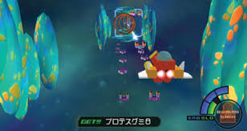

**Development challenges:**

Outline the main difficulties you think you might face when developing this project. Try to really think about each mechanic and be detailed where possible.

We will discuss these points in class.

* Obstacles
* Timer
* Will end with your high score.
* Rng or finite level
* Speed pickups.
* Collision

# **Sumo Soccer:** Game Design Brief

( Ash will be doing this assessment too! )

**Concept:**

‘*Sumo Soccer*’ is a top down, competitive multiplayer game that takes the physicality of sumo wrestling and fuses it with the fast paced action of soccer.

By combining the two, players will have multiple threats to consider:

1. The enemy scoring points
2. Being pushed/falling out of the ring

**Gameplay:**

At the start of the game, the players and ball are spawned into the arena.

The arena will be symmetrical with goal areas on either side. The ball will spawn in the center and players spawn next to their goal at the beginning of each round.

Players must rush to push the ball towards the opponent goal. The ball will bounce off the arena boundary, but players can fall through it.

A player is awarded ONE point if:

* the enemy falls out of the arena
* the ball rolls into the opponent’s goal

The level will reset after each point until one of the players wins best out of 3. Upon winning, the players can choose to play again.

**Core Mechanics:**

* 2 player same screen multiplayer
* Physics based conflict o Mass/momentum to interact with soccer ball and other players o Linear charge attack that temporarily prohibits steering
* 2-dimensional movement, controlled by WASD/arrow keys or controller joysticks
* Score tracking and round timer

**Minor Mechanics/Logic:**

* Top down fixed camera position looking over the entire arena
* Victory screen when either player scores best out of three
* Start menu with play and restart buttons
* Pause function that loads the menu

**Out of scope mechanics** (nice to haves)**:**

* Modular levels
* Main menu and level selections
* 4 player (2v2) support
* Pinball-esque hazards and obstacles (such as bouncy walls)
* Custom score goal
* Pickups (speed, weight, size, etc

**Inspirations/similar works:**

* Mario Party 64: Bumper Balls

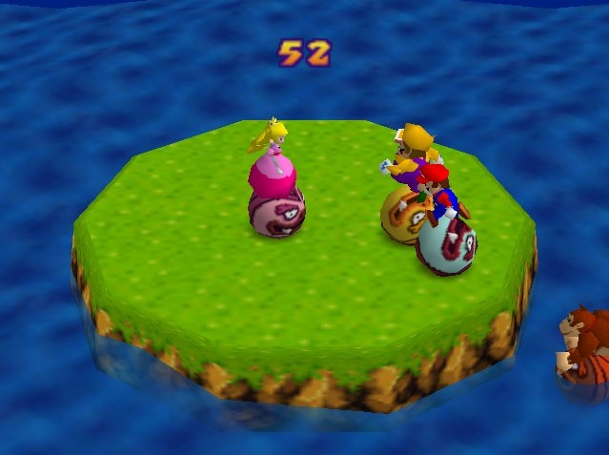

* Zorbs/Bubble Soccer:

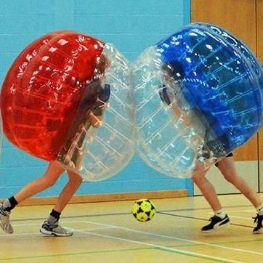

* Rocket League:

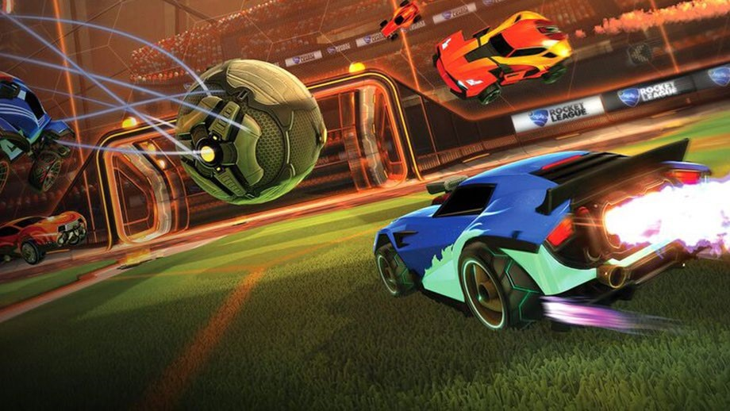

**Biggest development challenges** (detail anything you are unsure about)**:**

* I think the game inherits a lot of replayability from the round-based structure, however I am concerned that the ball will be too hard to control/aim.

* I don’t know how to make a main menu screen

* I don’t know how to add art/pretty stuff to the game